Kevin Tavara

ECE-350-001

10.07.2020

Lab 2: Servo Actuator Control

**Servo Sweep Python Script:**

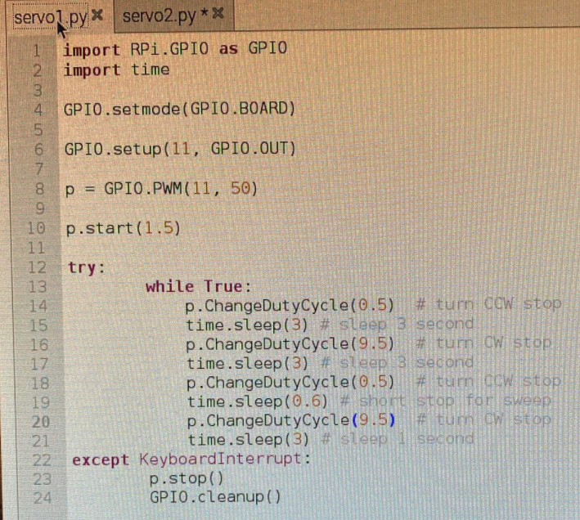

* Simple code outputting the change in duty cycle to GPIO17.

**Servo Protractor Python Script:**

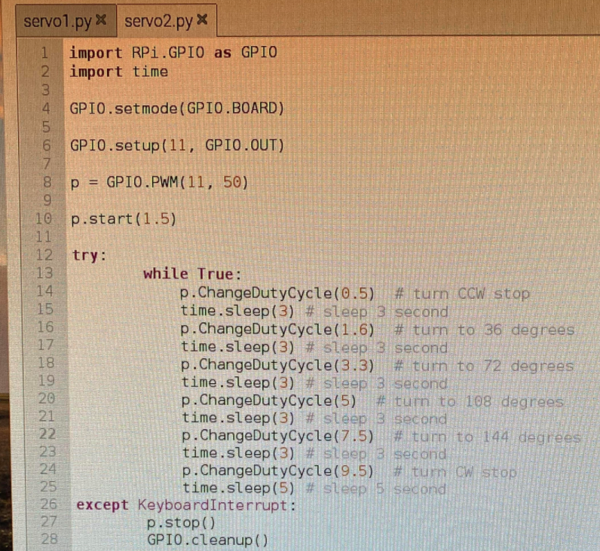

* Code written after a lot of trial and error. This code gave the most favorable outcome.

**Questions:**

1) What is the duty cycle?

Initial duty cycle = 1.5ms; Period = 20 ms; Duty Cycle = (1.5/20) *100 = 7.5%

2) Servo Position Angle vs. Command Duty Cycle Plot: